1. [“](\“An artificial intelligence framework and its bias for brain tumor segmentation and survival prediction\” and it was published in Computers in Biology and Medicine in April 2022)Multiclass semantic segmentation and quantification of traumatic brain injury lesions on head CT using deep learning: an algorithm development and multicenter validation study”

https://doi.org/10.1016/S2589-7500(20)30085-6

**Abstract**: CT is the most common imaging modality in traumatic brain injury (TBI). However, its conventional use requires expert clinical interpretation and does not provide detailed quantitative outputs, which may have prognostic importance. The study aimed to use deep learning to reliably and efficiently quantify and detect different lesion types.

**Methods**: Patients were recruited between Dec 9, 2014, and Dec 17, 2017, in 60 centers across Europe. An initial convolutional neural network (CNN) was trained and validated on expert manual segmentations (dataset 1). This CNN was used to automatically segment a new dataset of scans, which were then corrected manually (dataset 2). From this dataset, a subset of scans was used to train a final CNN for multiclass, voxel-wise segmentation of lesion types. The performance of this CNN was evaluated on a test subset. Performance was measured for lesion volume quantification, lesion progression, and lesion detection and lesion volume classification.

**Results**: Compared with manual reference, CNN-derived lesion volumes showed a mean difference of 0·86 mL for intraparenchymal hemorrhage, 1·83 mL for extra-axial hemorrhage, 2·09 mL for perilesional oedema, and 0·07 mL for intraventricular hemorrhage.

**Conclusion**: The study shows the ability of a CNN to separately segment, quantify, and detect multiclass hemorrhagic lesions and perilesional edema. These volumetric lesion estimates allow clinically relevant quantification of lesion burden and progression, with potential applications for personalized treatment strategies and clinical research in TBI.

1. “Detection of brain lesion location in MRI images using convolutional neural network and robust PCA”

https://doi.org/10.1080/00207454.2021.1883602

**Abstract**: Detection of brain tumors plays a critical role in the treatment of patients. Before any treatment, tumor segmentation is crucial to protect healthy tissues during treatment and to destroy tumor cells. Tumor segmentation involves the detection, precise identification, and separation of tumor tissues. In this paper, we provide a deep learning method for the segmentation of brain tumors.

**Methods**: In this article, they used a convolutional neural network (CNN) to segment tumors in seven types of brain disease consisting of Glioma, Meningioma, Alzheimer's, Alzheimer's plus, Pick, Sarcoma, and Huntington. First, they used the feature-reduction-based method robust principal component analysis to find tumor location and spot in a dataset of Harvard Medical School. Then they present an architecture of the CNN method to detect brain tumors.

**Results**: Results are depicted based on the probability of tumor location in magnetic resonance images. Results show that the presented method provides high accuracy (96%), sensitivity (99.9%), and dice index (91%) regarding other investigations.

**Conclusion**: The provided unsupervised method for tumor clustering and proposed supervised architecture can be potential methods for medical uses.

1. “An optimal segmentation with deep learning based inception network model for intracranial hemorrhage diagnosis”

https://doi.org/10.1007/s00521-021-06020-8

**Abstract**: The article provides an overview of the proposed method and its benefits. The proposed method uses a deep learning-based inception network to segment computer tomography (CT) images into different regions which are then used to detect intracranial hemorrhages. The proposed method was evaluated on a dataset of 100 CT images and achieved an average Dice similarity coefficient of 0.87.

**Methods**: The proposed method consists of three main steps: preprocessing, feature extraction, and segmentation. The preprocessing step involves image normalization and skull stripping. The feature extraction step involves extracting features from the preprocessed images using a deep learning-based inception network. Finally, the segmentation step involves segmenting the preprocessed images into different regions using a deep learning-based inception network.

**Results:** The proposed method was evaluated on a dataset of 100 CT images and achieved an average Dice similarity coefficient of 0.87. The proposed method was also compared with other state-of-the-art methods and achieved better performance.

**Conclusion**: The authors conclude that their proposed method can be used as an effective tool for detecting intracranial hemorrhages using CT images.

1. “Contribution of CT-Scan Analysis by Artificial Intelligence to the Clinical Care of TBI Patients”

<https://doi.org/10.3389/fneur.2021.666875>

The paper discusses how artificial intelligence can be used to analyze CT scans of traumatic brain injury (TBI) patients and how this analysis can help improve clinical care for these patients.

**Abstract**: Assessment of severity of TBI relies on clinical examination and initial brain imaging. Clinical examination is poor at the early phase of TBI and is based on the pupillary reactivity and the Glasgow Coma Score (GCS) that classifies TBI in 3 stages: mild, moderate, and severe1.

**Methods**: The authors used a retrospective cohort study design to evaluate whether AI-based analysis of CT scans could improve clinical care for TBI patients1.

**Results**: The authors found that AI-based analysis of CT scans could help improve clinical care for TBI patients by providing more accurate information about the severity of injury1.

**Conclusion**: AI-based analysis of CT scans could help improve clinical care for TBI patients by providing more accurate information about the severity of injury1.

1. “Brain Tumor Characterization Using Radiogenomics in Artificial Intelligence Framework”

<https://doi.org/10.3390/cancers14164052>

The article reviews the current state of brain tumor characterization (BTC) using radiogenomics in artificial intelligence (AI). BTC is the process of knowing the underlying cause of brain tumors and their characteristics through various approaches such as tumor segmentation, classification, detection, and risk analysis. Radiogenomics is the integration of imaging and genomic data to reveal the molecular features of tumors. AI is the use of computational methods to perform tasks that require human intelligence, such as learning, reasoning, and decision making.

The article discusses the challenges and opportunities of BTC using radiogenomics in AI, such as:

The need for large and diverse datasets of brain tumor images and genomic profiles to train and validate AI models.

The need for standardized and reproducible methods to acquire, preprocess, analyze, and interpret radiogenomic data.

The need for multidisciplinary collaboration among radiologists, pathologists, oncologists, geneticists, and computer scientists to develop and implement BTC solutions.

The potential for BTC using radiogenomics in AI to improve the diagnosis, prognosis, treatment planning, and monitoring of brain tumor patients.

The article also provides some examples of BTC applications using radiogenomics in AI, such as:

Predicting the histopathological grade and subtype of gliomas from magnetic resonance imaging (MRI) data using deep learning models.

Predicting the mutation status and survival outcome of glioblastoma patients from MRI data using machine learning models.

Predicting the response to chemotherapy and radiotherapy of brain metastases from computed tomography (CT) data using machine learning models.

The article concludes by highlighting some future directions for BTC using radiogenomics in AI, such as:

Developing more robust and interpretable AI models that can handle complex and heterogeneous radiogenomic data.

Developing more personalized and precise BTC solutions that can account for individual variability and tumor heterogeneity.

Developing more ethical and legal frameworks that can ensure the safety, privacy, and quality of BTC using radiogenomics in AI.

**Figures:**

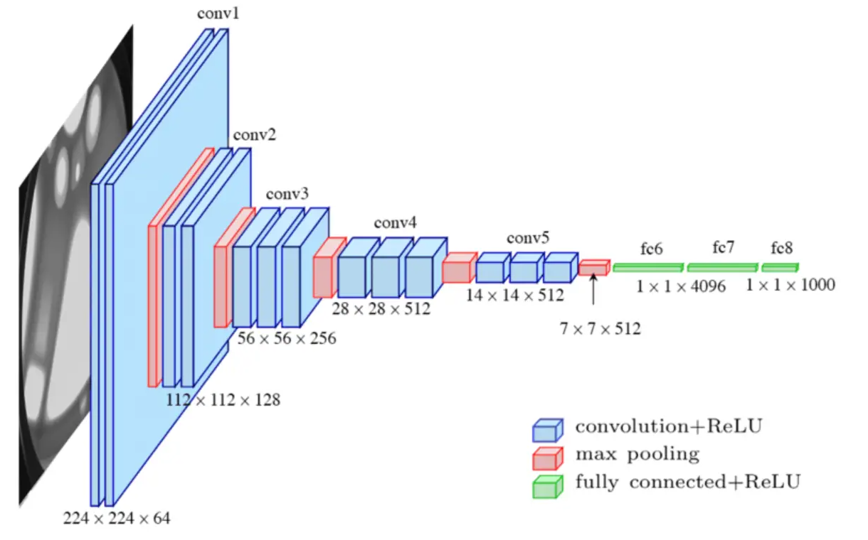

[Convolutional Neural Networks (CNN) are a type of neural network that are commonly used for image classification tasks**1**](https://towardsdatascience.com/convolution-neural-networks-a-beginners-guide-implementing-a-mnist-hand-written-digit-8aa60330d022). Here are some definitions of terms you asked for:

* ReLU (Rectified Linear Unit) is a real non-linear function defined by
* ReLU(x) = max(0,x). [It replaces all negative values received as inputs by zeros and acts as an activation function**2**](https://towardsdatascience.com/understand-the-architecture-of-cnn-90a25e244c7).
* Fully connected layer is a layer where the input layer nodes are connected to every node in the second layer. [Adding a fully-connected layer helps learn non-linear combinations of the high-level features outputted by the convolutional layers**1**](https://towardsdatascience.com/convolution-neural-networks-a-beginners-guide-implementing-a-mnist-hand-written-digit-8aa60330d022).
* Max pooling is a type of operation that is typically added to CNNs following individual convolutional layers. [When added to a model, max pooling reduces the dimensionality of images by reducing the number of pixels in the output from the previous convolutional layer](https://deeplizard.com/learn/video/ZjM_XQa5s6s).

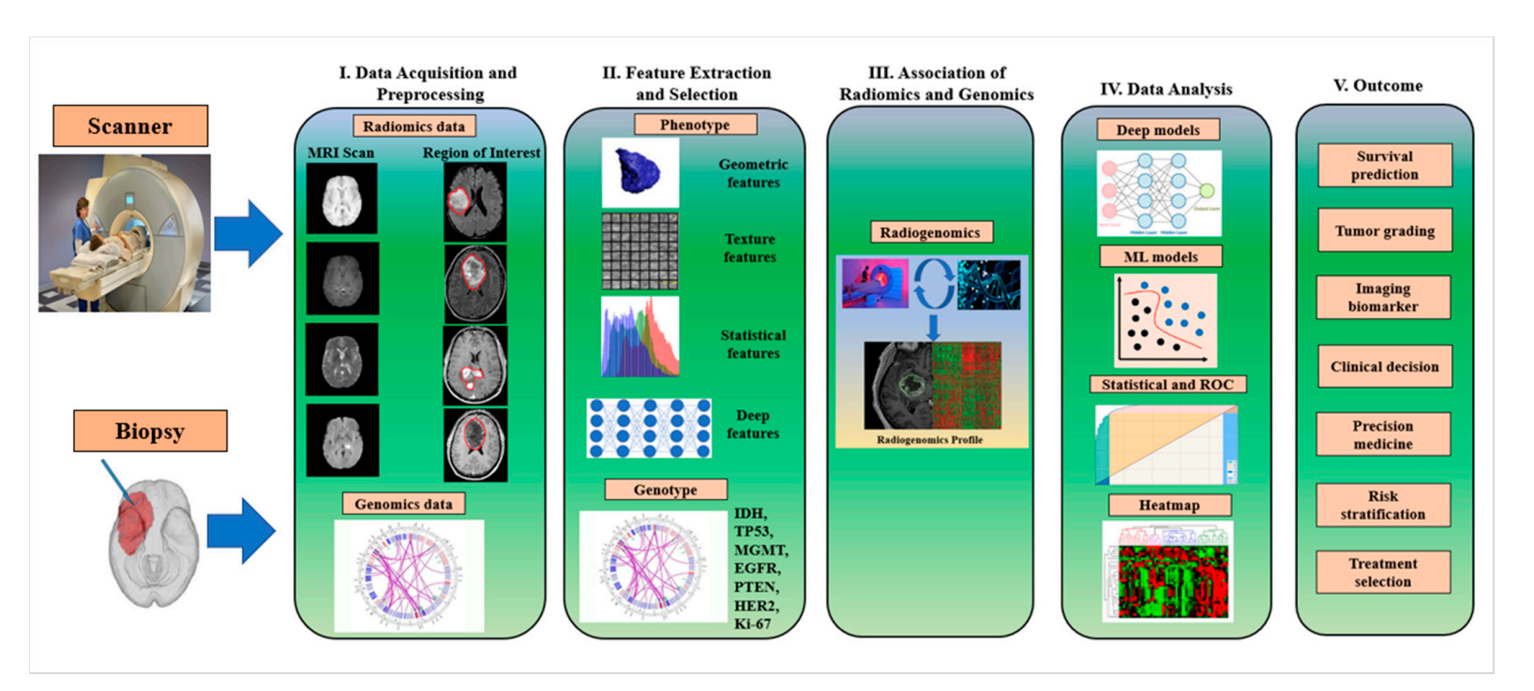

The workflow of radiogenomics for brain tumor genomics and disease characterization. Notes: IDH: isocitrate dehydrogenase, TP53: tumor protein53, MGMT: O6-methylguanine DNA methyltransferase, EGFR: epidermal growth factor receptor, PTEN: phosphatase and tensin homolog, methyltransferase, EGFR: epidermal growth factor receptor, PTEN: phosphatase and tensin homolog, HER2: human epidermal growth factor receptor 2.

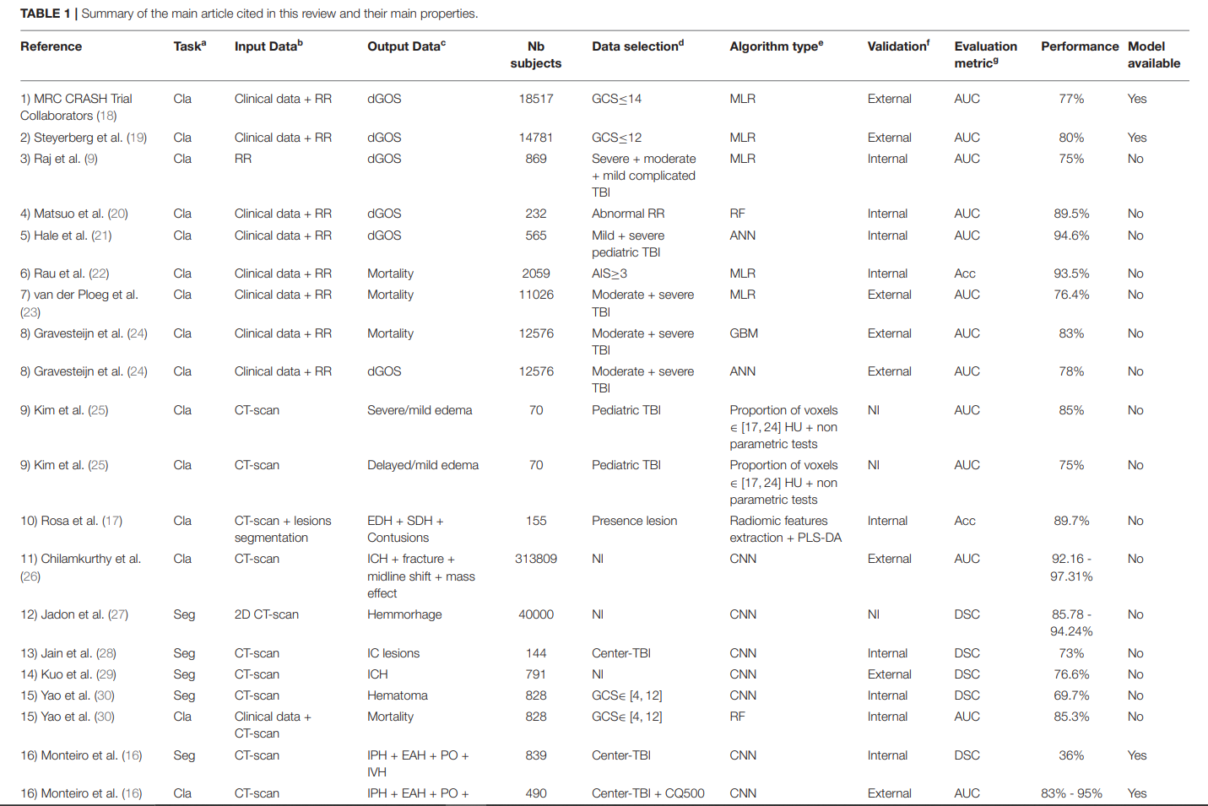

aTask: Cla, Classification; Seg, Segmentation. bInput Data: clinical data = metrics representing demography or physiology, RR, radiological reading metrics manually retrieved from CT scan and CT scan, computed tomography image. cOutput Data: dGOS, dichotomized Glasgow Outcome Score, EDH, extra dural hemmorhage; SDH, subdural hemorrhage; ICH, intracranial hemorrhage; IC, intracranial; PO, oerilesional edema; IVH, intraventricular hemorrhage. dData selection: GCS, Glasgow Coma Score; AIS, Abbreviated Injury Scale; NI, no information; Center-TBI and CQ500: public databases containing TBI CT scans. eAlgorithm type: MLR, multivariate logical regression; RF, random forest; ANN, artificial neural network; CNN, convolutional neural network; GBM, gradient boosting machine; HU, Hounsfield Units. fValidation: NI, no information. gEvaluation metric: AUC, area under the curve; Acc, accuracy; DSC, Dice similarity coefficient.

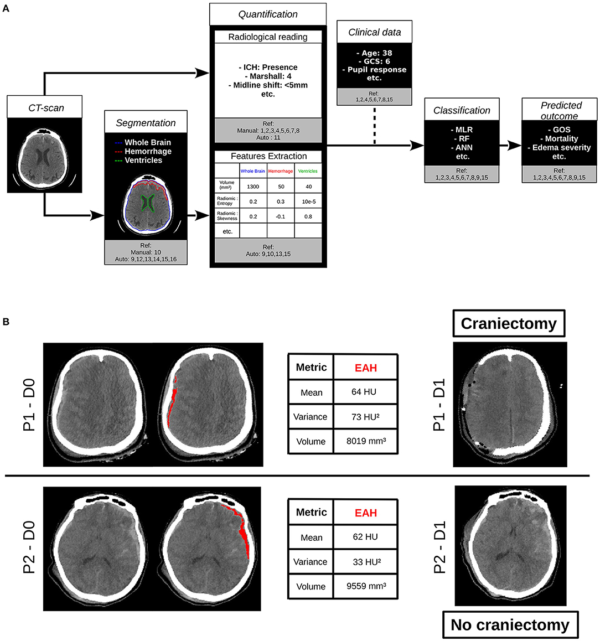

(A) Contribution of computed tomography (CT) scan analysis by artificial intelligence to the clinical care of traumatic brain injury (TBI) patients. References

and terms are defined in Table 1. (B) Example of the use of artificial intelligence (AI) algorithms on clinical routine. CT scans of two patients (P1 and P2) at D0 were

quantified with state of the art algorithms. On the right, CT scans of the same two patients acquired at D1 are shown. P1 and P2 had different clinical care. P1

underwent a decompressive craniectomy and not P2. Biggest extra axial hemorrhage (EAH) lesion was segmented with Brain Lesion Analysis and Segmentation Tool

for Computed Tomography (BLAST-CT) (16) and radiomic metrics on this region of interest (ROI) were extracted as in (17). At first sight, the two lesions have the same profile, with equivalent volumes and means, but the variance of P1 is higher than twice the one of P2. That could for instance be a biomarker evaluated in further

studies to predict the need for craniectomy. ICH, intracranial hemorrhage; GCS, Glasgow Coma Score; MLR, multivariate logical regression; RF, random forest; ANN,

artificial neural network; GOS, Glasgow Outcome Score; CT scan, computed tomography image; Ref, References; HU, Hounsfield Units; ROI, region of interest; EAH, extra axial hemorrhage; D, day.

***Author: Abbas Mazrouei Sebdani***